Dear Parents/Guardians of piano players,

St Peter’s Girls’ School Piano Eisteddfod

In week 7 of Term 2, the Arts Department will hold St Peter’s Girls’ Piano Eisteddfod. This eisteddfod is open to all students in the Junior and Middle school who play piano and will be held on Thursday 16 June from 8.45am in MB120. Parents are invited to attend their daughter/s performance.

Girls will have the opportunity to perform a piece to a panel of judges, who will critique their performance based on accuracy, technique and musicality for their specific music level.

This year we will hold a recital on 23 June and will invite some students of varying levels to perform in the evening. Parents are welcome to attend.

This is a great opportunity for girls to perform in a supportive environment and get some feedback on their playing.

Girls are asked to play one piece that best displays their musicality and technical ability, at their own musical level. There will be no minimum or maximum time limit. While the eisteddfod aims to give our top piano players a chance to perform, the aim is to give performers of all levels the opportunity to be represented.

Please fill out the slip below if you wish to be a part of this event. We ask for slips to be returned to Ms Phillips in the Arts Office by Friday 3 June. Your daughter/s will then receive a time slot to perform in the eisteddfod. Students/Parents will be notified by email if they have been chosen to perform at the recital.

Yours sincerely,
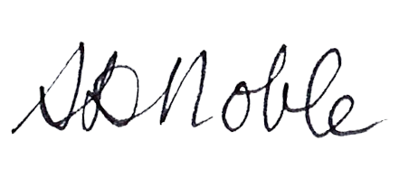
Sari Noble
Acting Director of Music

"
PIANO EISTEDDFOD - Please sign and return to Ms Phillips in the Arts Office by Friday 3 June

I give consent for ___________________________________________ (student’s name) in _________ (Home Group) to participate in the Piano Eisteddfod on 16 June.

Title of piece: __________________________________________________________________________

Composer: _________________________________ Approximate Length of piece: _______________

Name of piano tutor: ___________________________ Approximate AMEB level: _________________

Years playing piano: ______________

Parent/Guardian Name: _____________________________ Parent/Guardian Signature: ______________________

